1. INTRODUCTION;

Economic freedom is the fundamental right of every human to control his or her own labor and property. In an economically free society, individuals are free to work, produce, consume, and invest in any way they please. In economically free societies, governments allow labor, capital, and goods to move freely, and refrain from coercion or constraint of liberty beyond the extent necessary to protect and maintain liberty itself.

For much of human history, most individuals have lacked economic freedom and opportunity, condemning them to poverty and deprivation.

Today, we live in the most prosperous time in human history. Poverty, sicknesses, and ignorance are receding throughout the world, due in large part to the advance of economic freedom. In 2022, the principles of economic freedom that have fueled this monumental progress are once again measured in the Index of Economic Freedom, an annual guide published by The Heritage Foundation, Washington's No. 1 think tank

1.1 PURPOSE

To accomplish this, we have to complete all the activities listed below,

* Define Problem / Problem Understanding
  + Specify the business problem
  + Business requirements
  + Literature Survey
  + Social or Business Impact.
* Data Collection & Extraction from Database
  + Collect the dataset,
  + Storing Data in DB
  + Perform SQL Operations
  + Connect DB with Tableau
* Data Preparation
* Prepare the Data for Visualization
* Data Visualizations
  + No of Unique Visualizations
* Dashboard
  + Responsive and Design of Dashboard
* Story
  + No of Scenes of Story
* Performance Testing
  + Amount of Data Rendered to DB ‘
  + Utilization of Data Filters
  + No of Calculation Fields
  + No of Visualizations/ Graphs
* Web Integration
  + Dashboard and Story embed with UI With Flask
* Project Demonstration & Documentation
  + Record explanation Video for project end to end solution
  + Project Documentation-Step by step project development procedure

1. PROBLEM DEFINITION AND DESIGN THINKING

2.1 EMPATHY MAP

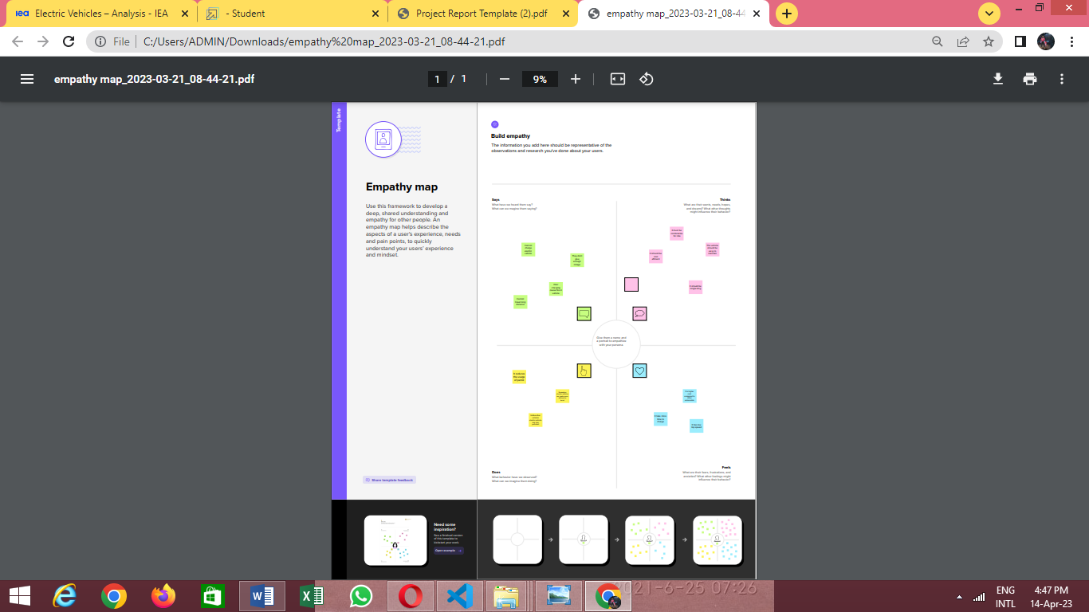

2.2 BRAINSTROMING MAP

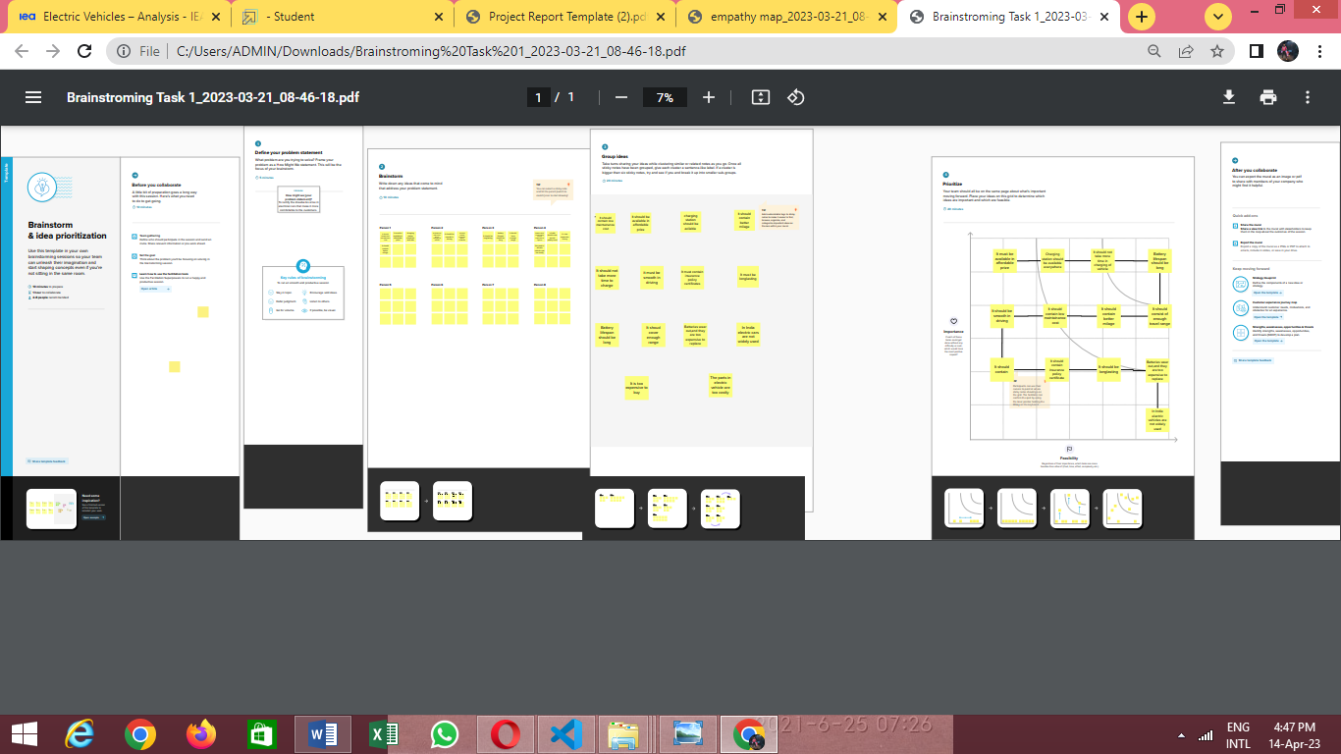

3.RESULT

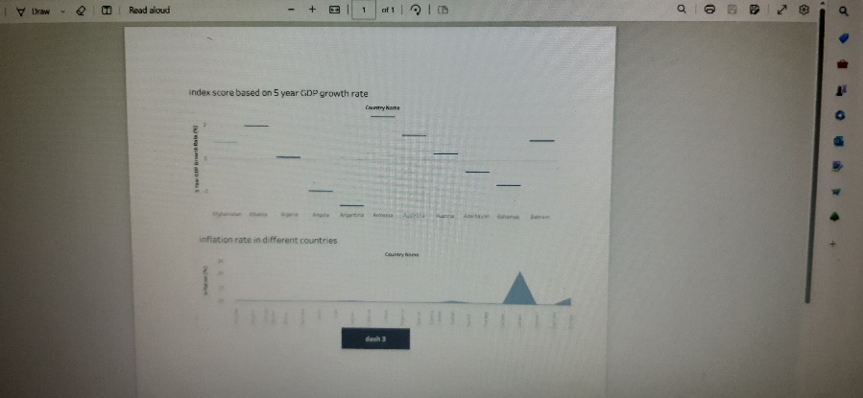

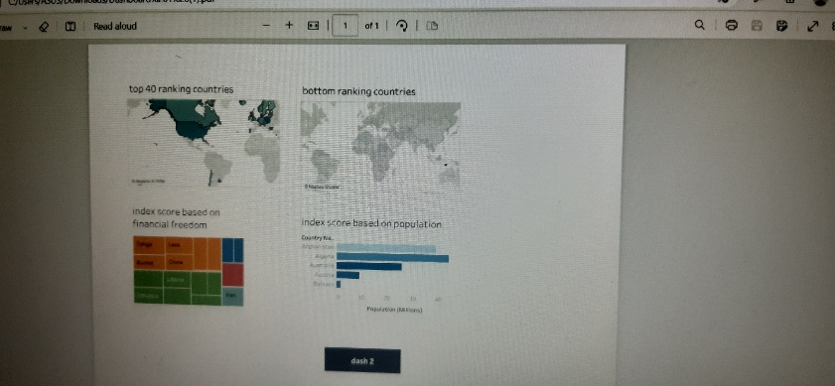

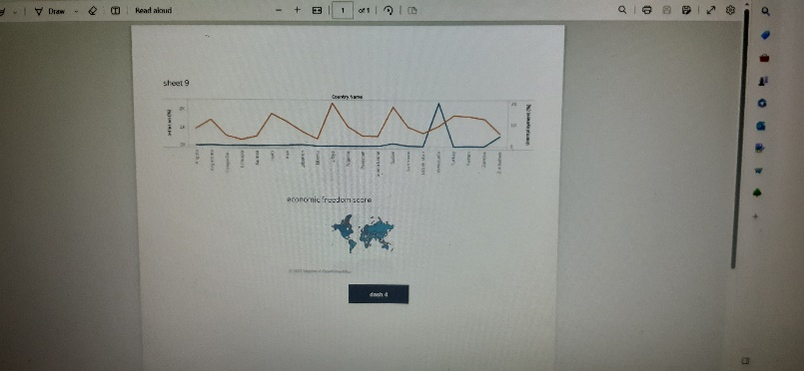

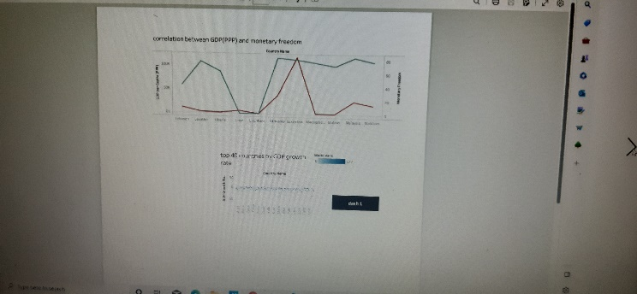

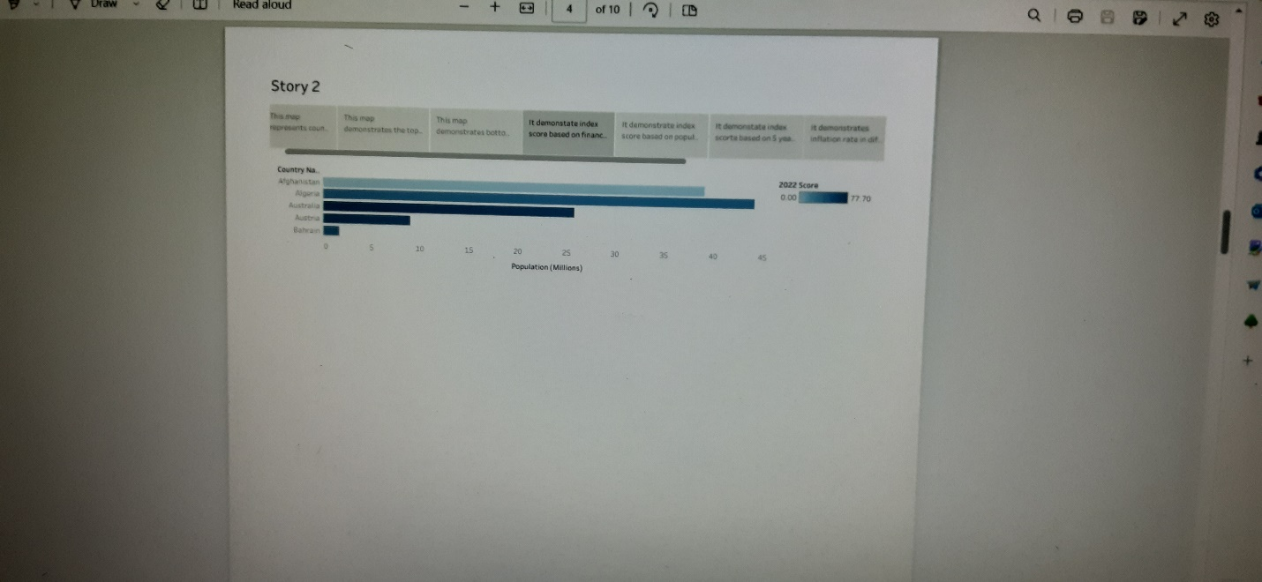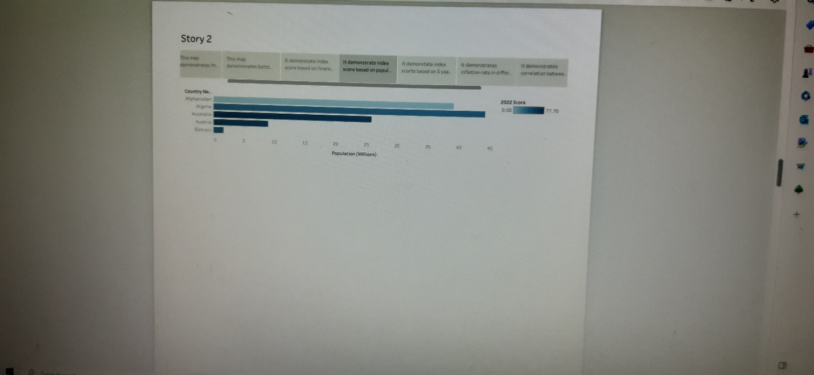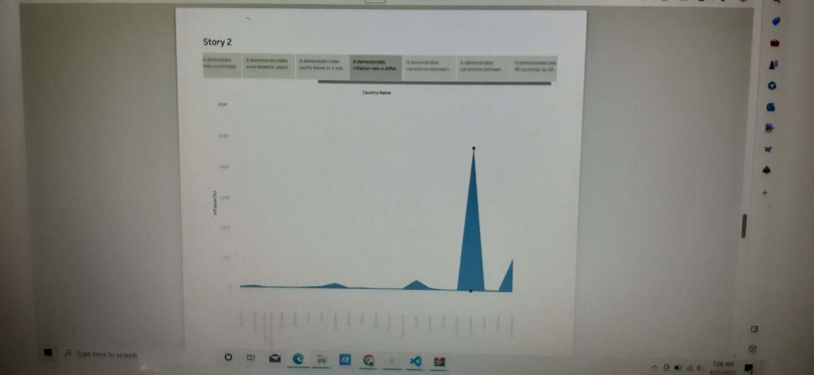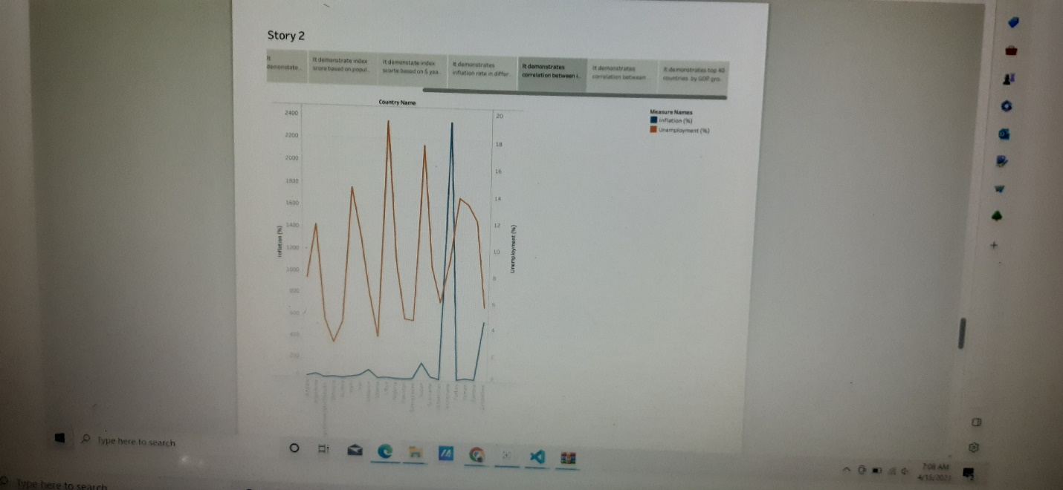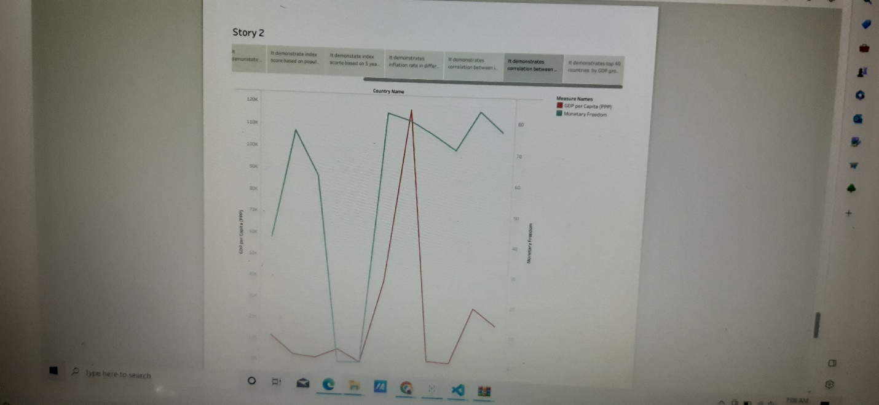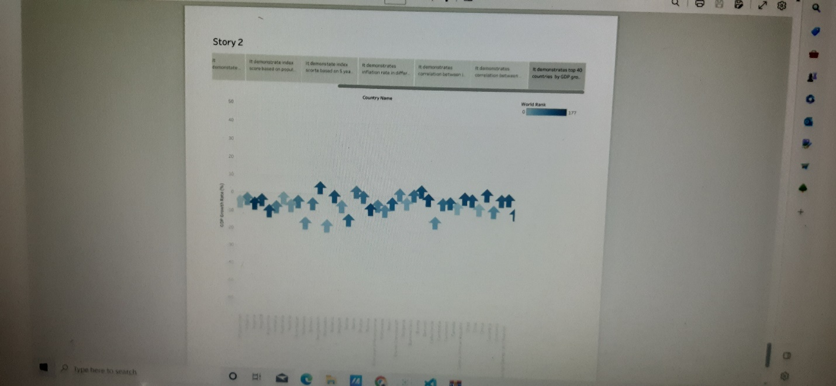

|  |  |
| --- | --- |
| ADVANTAGES | DISADVANTAGES |
| Consumer Sovereignty | * Unemployment and Inequality. |
| Absence of Bureaucracy | **Excessive Power of Firms** |
| Motivational Influence of Free Enterprise | NOT BE APPILCABLE |
| Optimal Allocation of Resources | POOR QUALITY |
| HELPS THE NATION INCOME | MERITS GOOD |
|  |  |
|  |  |
|  |  |

5.APPLICATION;

An index of economic freedom measures jurisdictions against each other in terms of parameters such as trade freedom, tax burden, judicial effectiveness, and more. These factors may be weighted according to their influence on economic freedom and compiled into a single score that allows for a ranking. The ranking can be done on a country basis or can look at wider regions or smaller subnational units like states.

The most widely referenced index of economic freedom is produced by the Heritage Foundation, a conservative American think tank. The Fraser Institute, a Canadian think tank, also publishes a well-known index of economic freedom.

CONCLUSION;

Economic freedom is the ability of individuals to make their own economic decisions without interference or limitations by government or government’s protection of anti-market behavior in favor of powerful groups and these group’s abuse of this power to limit market choices of other.

Future scope:

We take our “We grow talent, talent grows us” culture belief to heart by focusing on developing our Moment Makers. An ever-growing Radisson Academy offer aims to equip you with key skills and boost your potential through customized training programs right from your day one. We are dedicated to individual development and have a strong performance culture that facilitates your career growth at all levels